**CS359 - Computer Network Lab**

**Lab 1a: Wireshark Intro**

Tarusi Mittal 1901CS65

**Question 1:** List 3 different protocols that appear in the protocol column in the unfiltered packet-listing window in step 7 above.

Ans: 3 different protocols captured are:

* DNS: DNS, or the Domain Name System, translates human readable domain names to machine readable IP addresses
* UDP: User Datagram Protocol (UDP) – a communications protocol that facilitates the exchange of messages between computing devices in a network. It's an alternative to the transmission control protocol (TCP).
* TCP: The Transmission Control Protocol (TCP) is a transport protocol that is used on top of IP to ensure reliable transmission of packets.

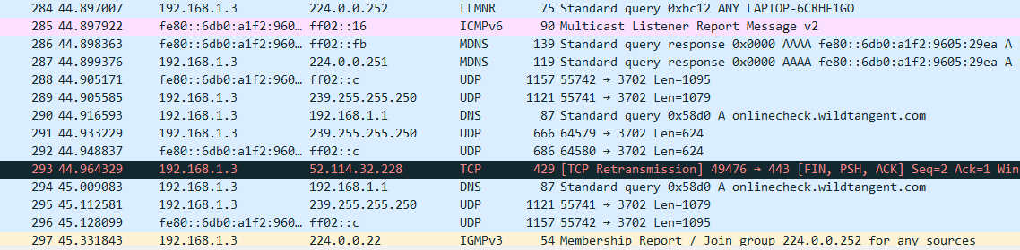

**Question 2**: How long did it take from when the HTTP GET message was sent until the HTTP OK reply was received? (By default, the value of the Time column in the packetlisting window is the amount of time, in seconds, since Wireshark tracing began. To display the Time field in time-of-day format, select the Wireshark *View* pull down menu, then select Time *Display Format*, then select *Time-of-day*.)

Ans:

Time when HTTP Get request was sent: 13:34:26.452865

Time when HTTP OK reply was received: 13:34:26.898620

Time Taken = 0.445755 seconds

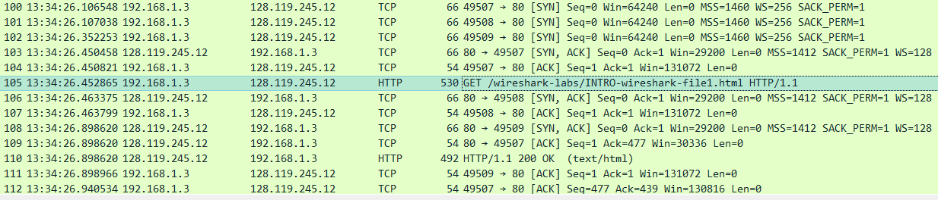

**Question 3**: What is the Internet address of the gaia.cs.umass.edu (also known as wwwnet.cs.umass.edu)? What is the Internet address of your computer?

Ans:

IP address of gaia.cs.umass.edu : 128.119.245.12

IP address of my computer : 192.168.1.3

**Question 4:** Print the two HTTP messages (GET and OK) referred to in question 2 above. To do so, select *Print* from the Wireshark *File* command menu, and select the “*Selected Packet Only”* and *“Print as displayed”* radial buttons, and then click OK.

Ans:

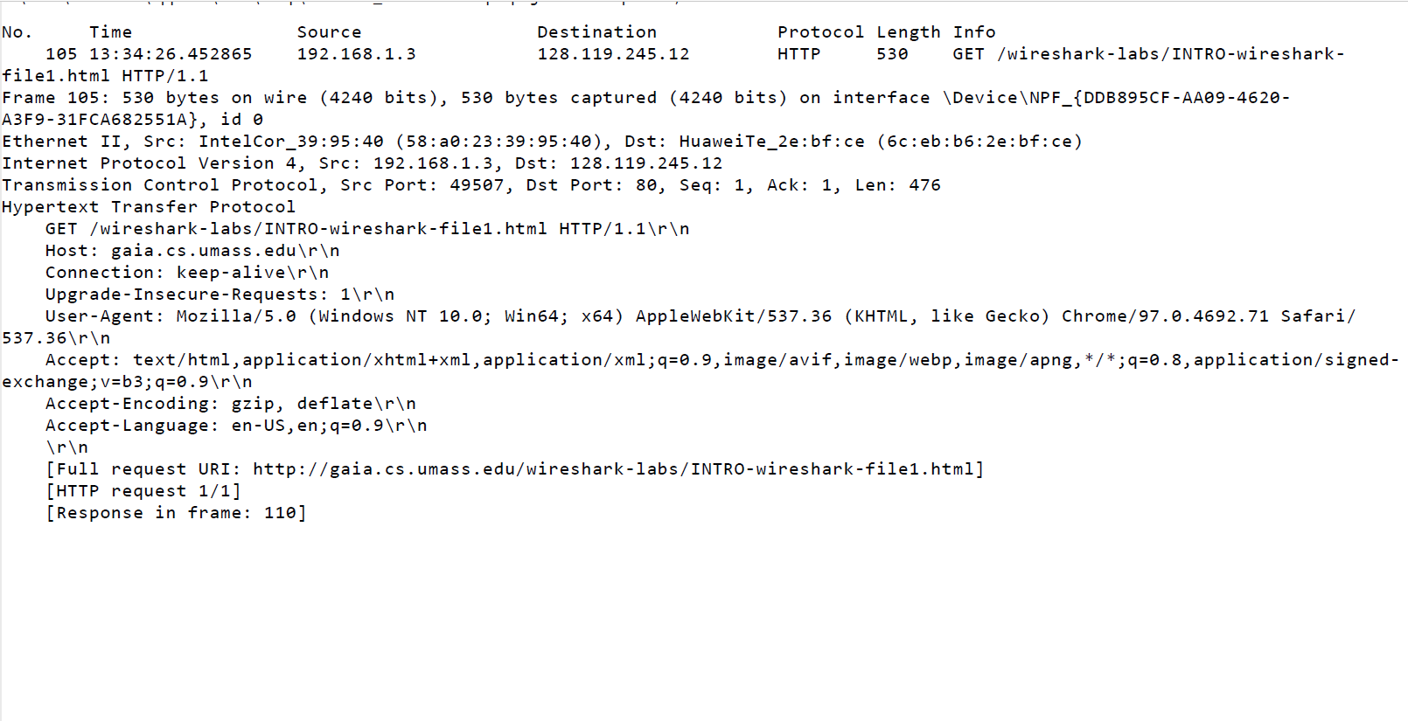

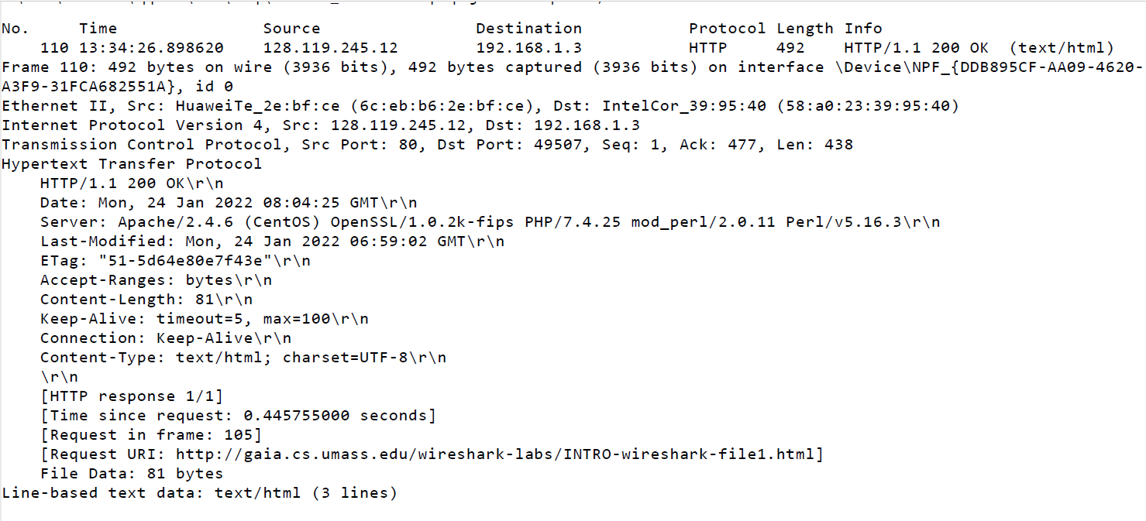

-X-X-X-X-X-X-X-X-X-X-X-X-X-X-X-X-X-X-X-X-X-X-X